AIM
DOWNLOAD ATTACHMENTS
MD.120 deployment Instructions

Author: Varun Sai Kumar Jonna
Creation Date: JUNE 05, 2024
Last Updated:
Version: 1.0

Title, Subject, Last Updated Date, Reference Number, and Version are marked by a Word Bookmark so that they can be easily reproduced in the header and footer of documents. When you change any of these values, be careful not to accidentally delete the bookmark. You can make bookmarks visible by selecting Tools->Options…View and checking the Bookmarks option in the Show region.

Approvals:
<Approver 1>
<Approver 2>
To add additional approval lines, press [Tab] from the last cell in the table above.
 Copy Number _____
You can delete any elements of this cover page that you do not need for your document. For example, Copy Number is only required if this is a controlled document and you need to track each copy that you distribute.

Document Control

Change Record
3
Date | Author | Version | Change Reference
 |  | Ver 1.0

Reviewers

Name | Position

Distribution

Copy No. | Name | Location
The copy numbers referenced above should be written into the Copy Number space on the cover of each distributed copy. If the document is not controlled, you can delete this table, the Note To Holders, and the Copy Number label from the cover page.

Note To Holders:
If you receive an electronic copy of this document and print it out, please write your name on the equivalent of the cover page, for document control purposes.
If you receive a hard copy of this document, please write your name on the front cover, for document control purposes.
Contents
Document Control iii
Creating Connections For Integration 1
- Creation Of FTP Adapter. 1
- Creation Of ERP Adapter To Download Attachments 5
- Creation Of SOAP Adapter To Call BI Report 6
Creating Integration 7
Run The Integration 21
Integration Tracking 23
Open and Closed Issues for this Deliverable 24
Open Issues 24
Closed Issues 24

To update the table of contents, put the cursor anywhere in the table and press [F9]. To change the number of levels displayed, select the menu option Insert->Index and Tables, make sure the Table of Contents tab is active, and change the Number of Levels to a new value.

Create Connections for Download Attachments
Creation of adapters:
- To Download Attachments we are using three Adapters ftp, Soap and ERP
- To create connections, navigate to connections tab and select create option then select desired adapter as shown below.
Adapter :- it helps to store the required credentials to make a connection.

Creation Of FTP :
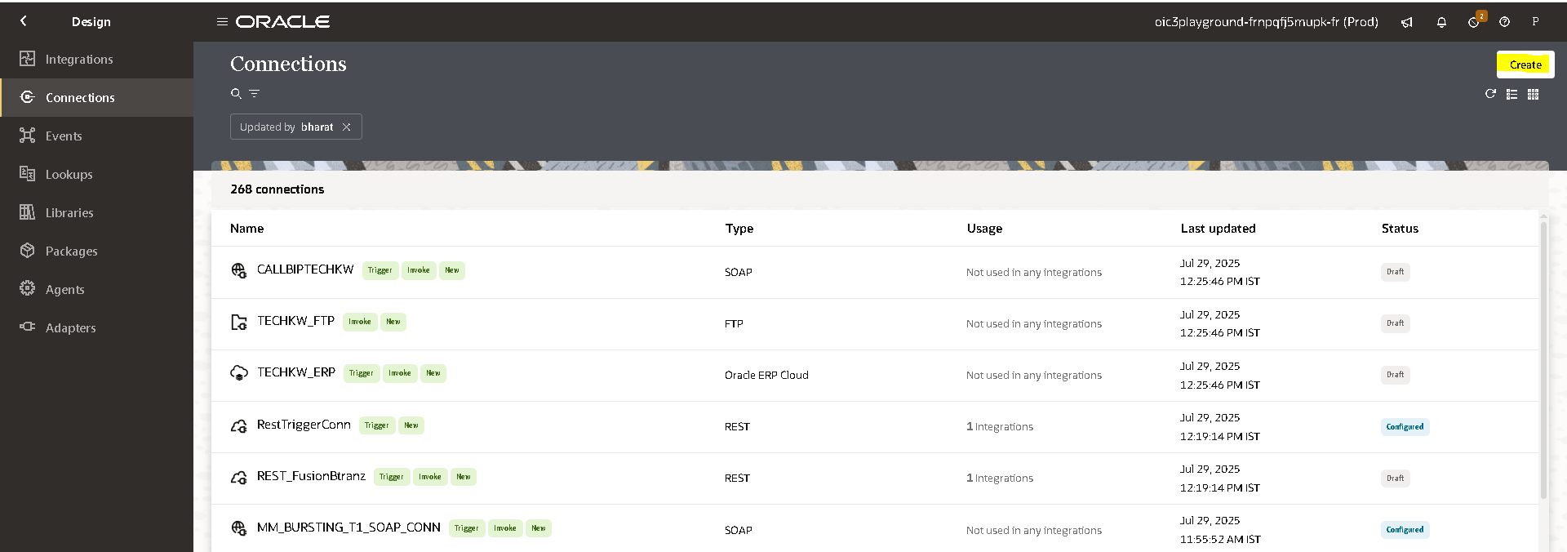

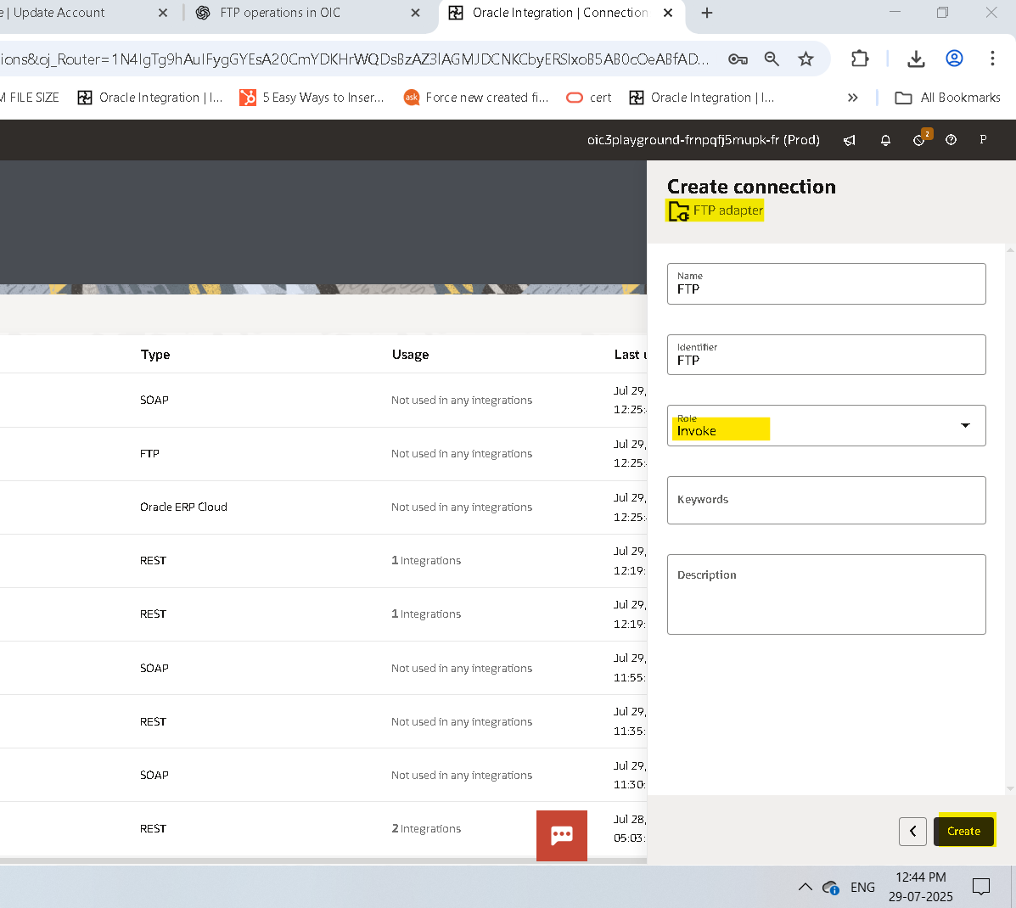

Connection Role :- a trigger means the connection where the integration receives the message. An invoke means the connection where the integration sends the message.
- Based on our requirement we choose trigger and invoke role connection.
- After clicking on create we need to pass the required Data along with the login credentials.
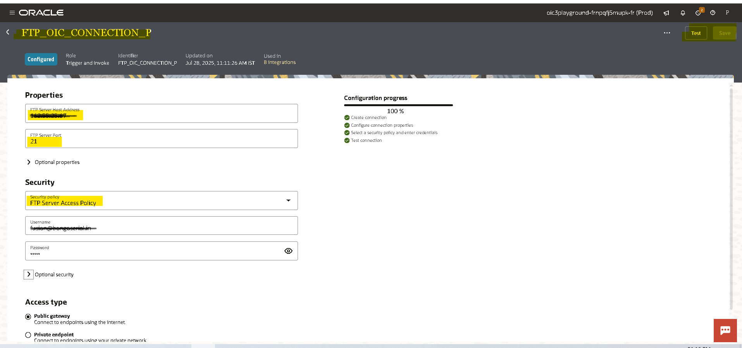
- Then click on test,popup will appear as shown above then select diagnose & test.
- After successful testing save your connection.
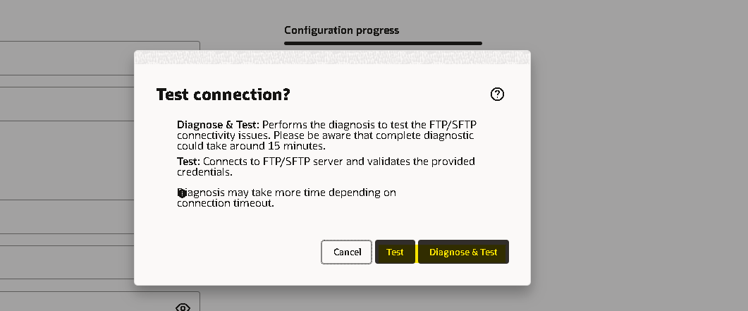
Creation Of ERP Connection For Download Attachments:-
role trigger and invoke
- Navigate to connections tab then select the adapter based on the connection(ERP)
- ERP Cloud Host: URL of Fusion
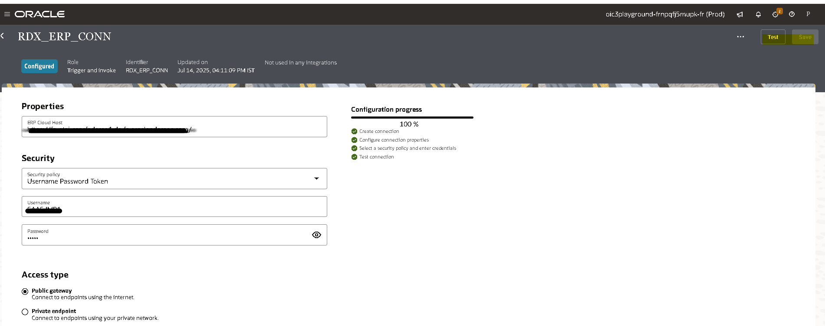
- Enter the URL and select security as basic authentication and enter fusion credentails as username and password.
- Then click on test, after testing successfully save the connection.
Creation of soap connection For Calling BI report :-
- For Download Attachement we are calling the BIP Report to get DIDs by passing ENTITYNAME and as parameter.
- We need to create another SOAP connection to call BI report.
- WSDL URL :- https//<<Fusion URL>> /xmlpserver/services/ExternalReportWSSService?wsdl.
- Enter the WSDL URL and select security as basic authentication and enter fusion credentails as username and password.
- Then click on test, after testing successfully save the connection.
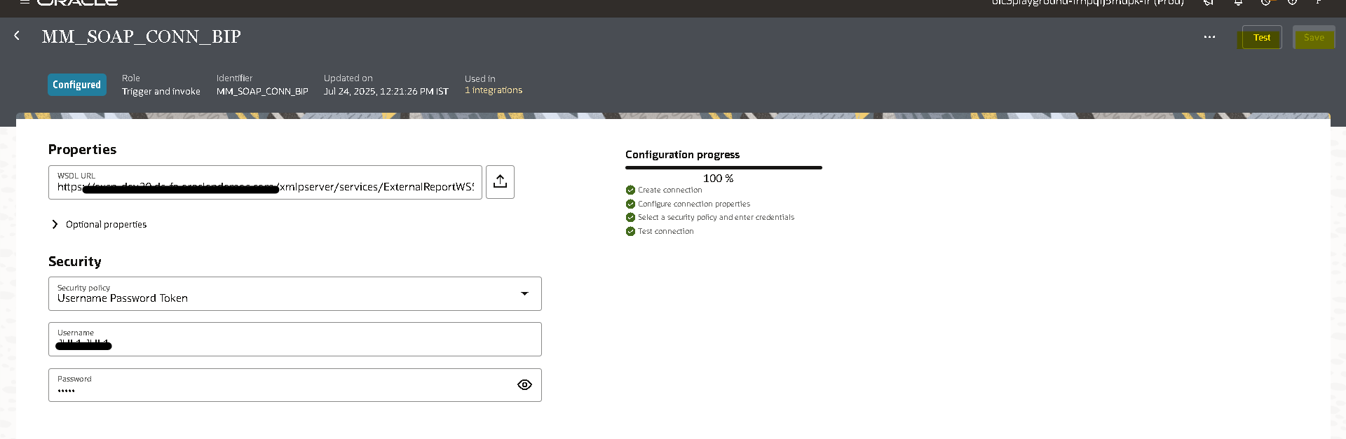
Creation Of Lookups:
- we have to create a lookup to change the destination FTP path based on the Entity Name.
- Navigate to lookup tab and click on create to create a new lookup or else we can also import a file.
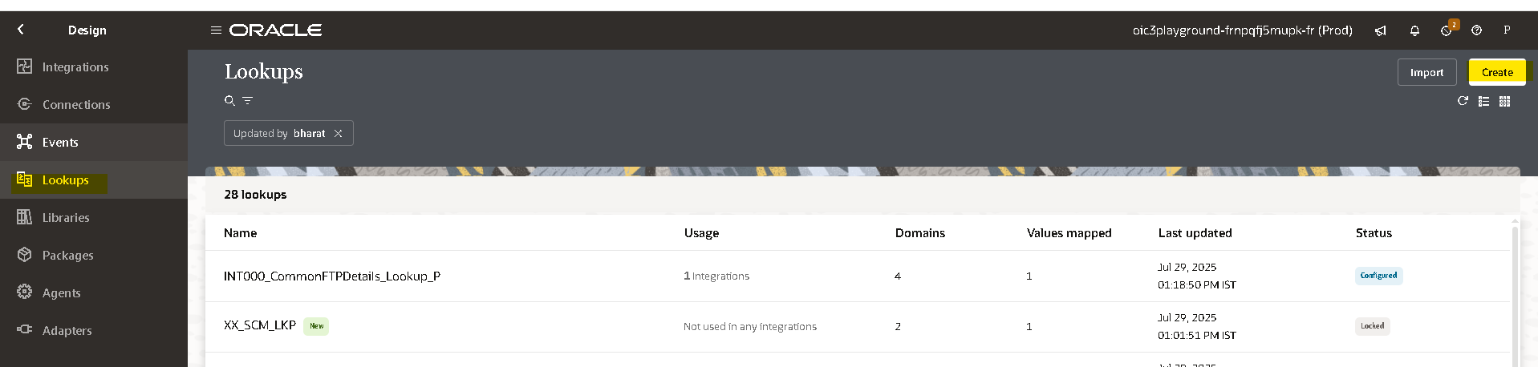
- Create two columns EntityName and FTP File Path to enter the data as below and click on Save.
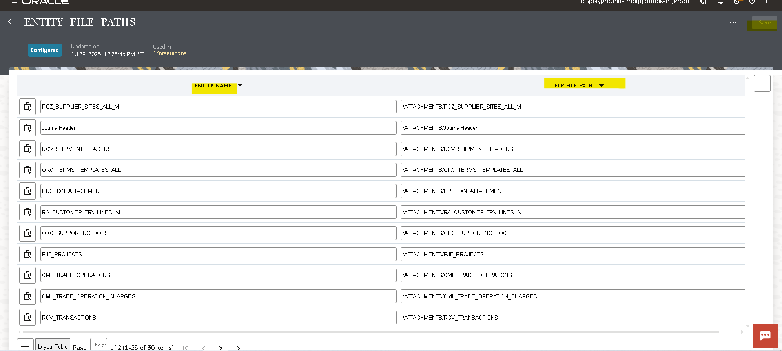

Creation Of Integration:
- Navigate to integration tab then click on create option and select scheduled orchestration.
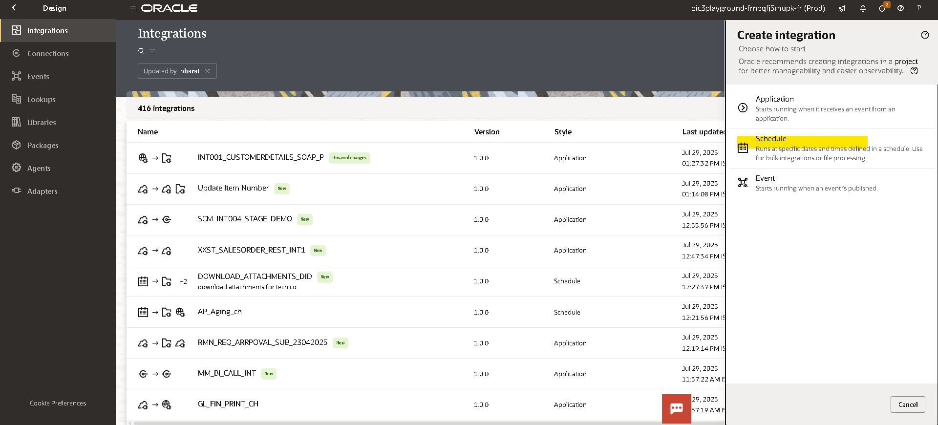

- Try to create with a unique name for identification.
- Once the integration is created select the action button on the right side of the Tab.
- Create a schedule parameter ENTITYNAME by right click on the scheduler
- Drag the Assign action and place it on plus (+) icon in the integration.
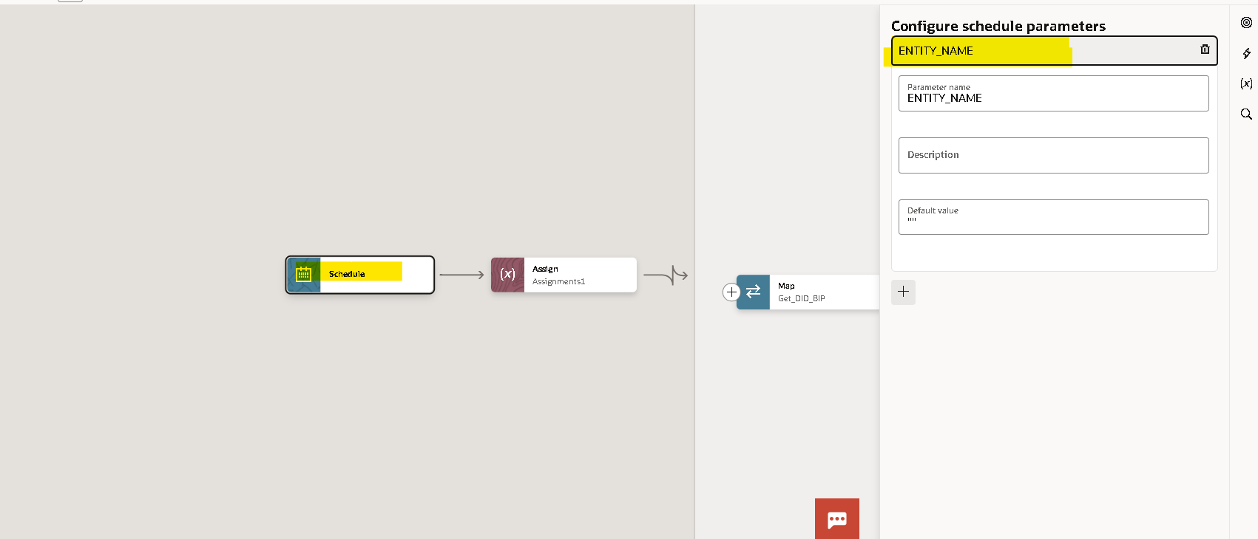
- Give a name for the assign action and click on create.
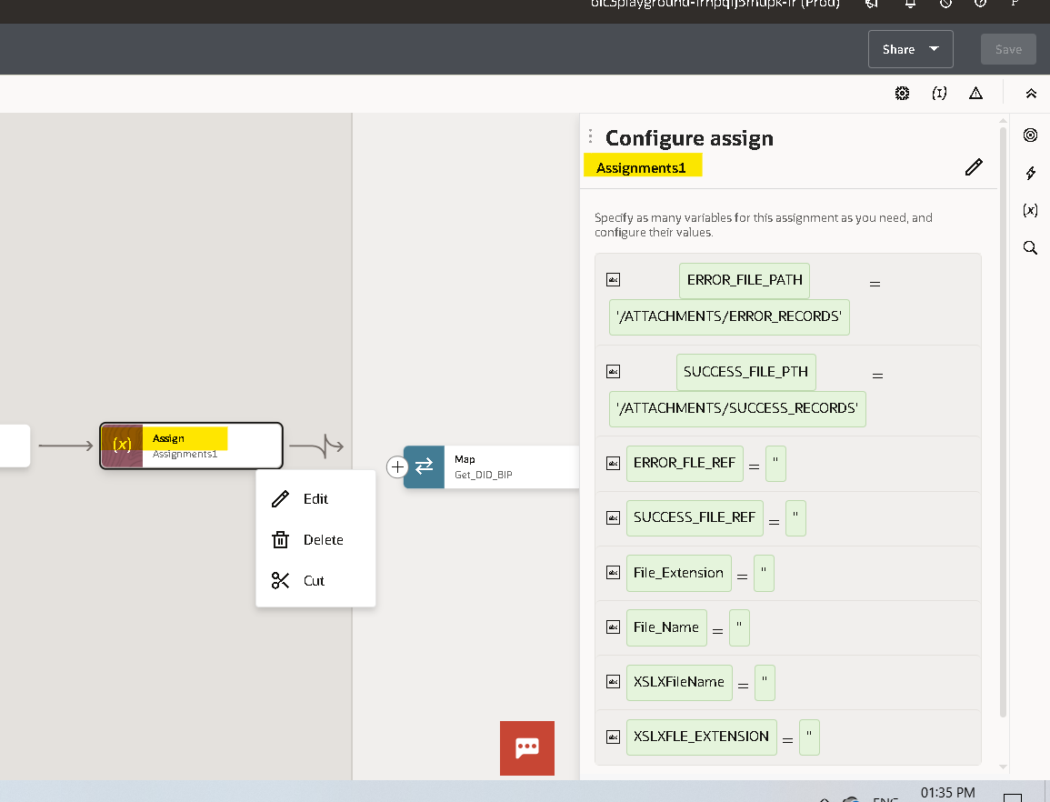
- Give the name of the variable and click on the pencil icon to assign the value for the variable.
- To add one more variable you can select plus (+) icon.
Note :- To Assign/Mention The Values We Need To Use Single Quotes .

- Here we created eight variables.

- ERROR_FILE_PATH : To store the errored records directory.
- SUCCESS_FILE_PATH : To store the success records directory.
- XSLXFLE_EXTENSION, XSLXFileName, File_Name, File_Extension : are used to store the attachment data file
- SUCCESS_FILE_PATH_REF : To Store the Success records Data.
- ERROR_FILE_REF : To Store the Error records Data.

- Select the Plus (+) Icon and select Scope.

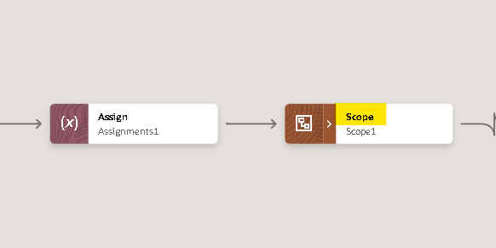
- Search for SOAP adapter to call BI report by clicking on the plus (+) icon.
- Select Operation as Run Report click on next.
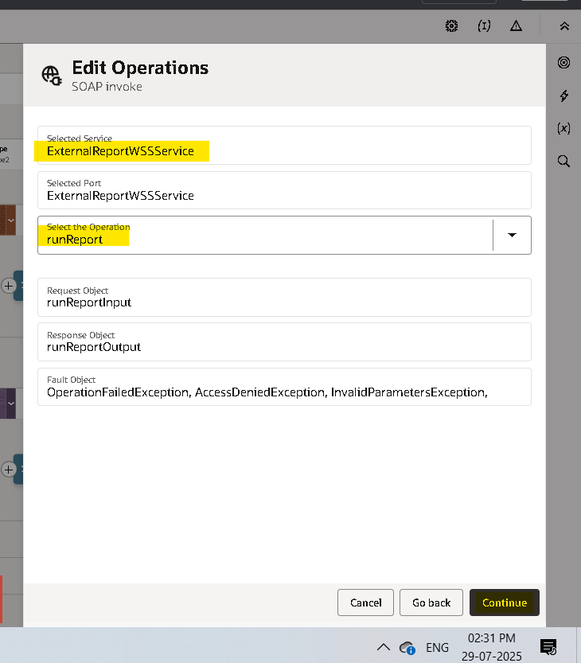
- Check the details in the summery and click on Finish.
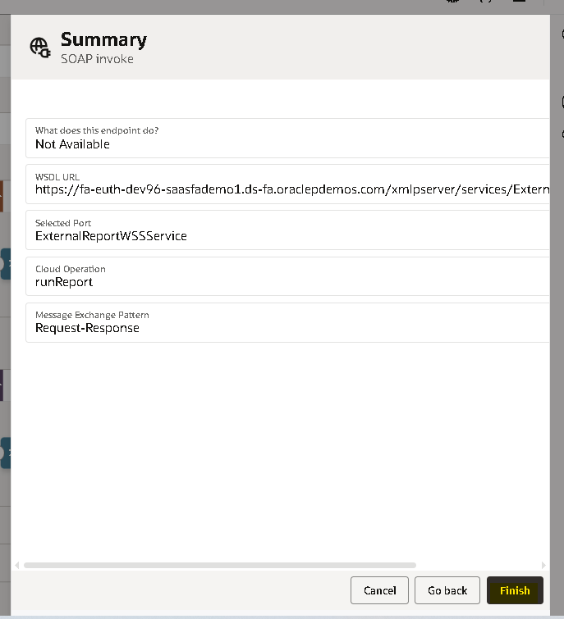
- Mapper will be created for SOAP adapter to call the BIP report edit the mapper and hardcode the mandatory fields.
- Attribute Format : Format of BI report output “CSV”
- Report Absolute Path : Location path where the BI report is saved.
- Size Of Data Chunk Download : Since our response will be less than 10 MB it will be ‘-1’
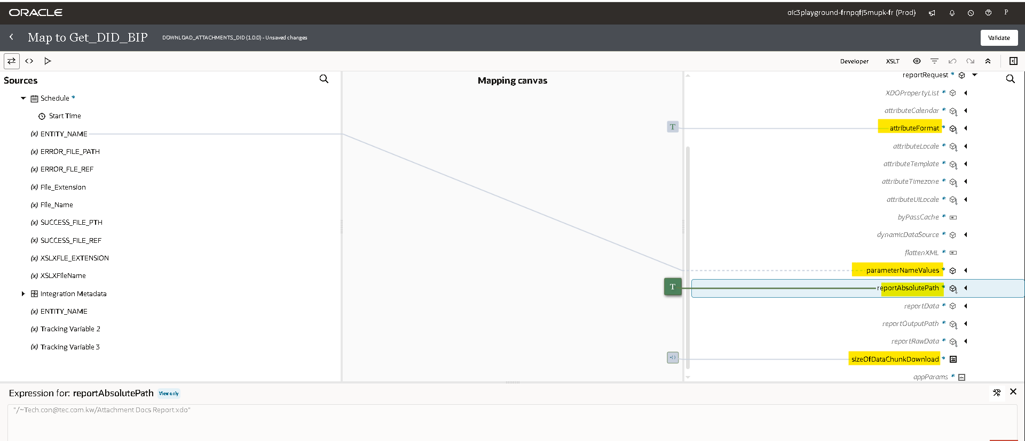
- In parameterNameValues enter name as EntityName and values as the schedule parameter.
- Once you enter click on Validate and close.
- We need to read the response of the Bip Report add the stage file adapter and select read entire file as Operation.
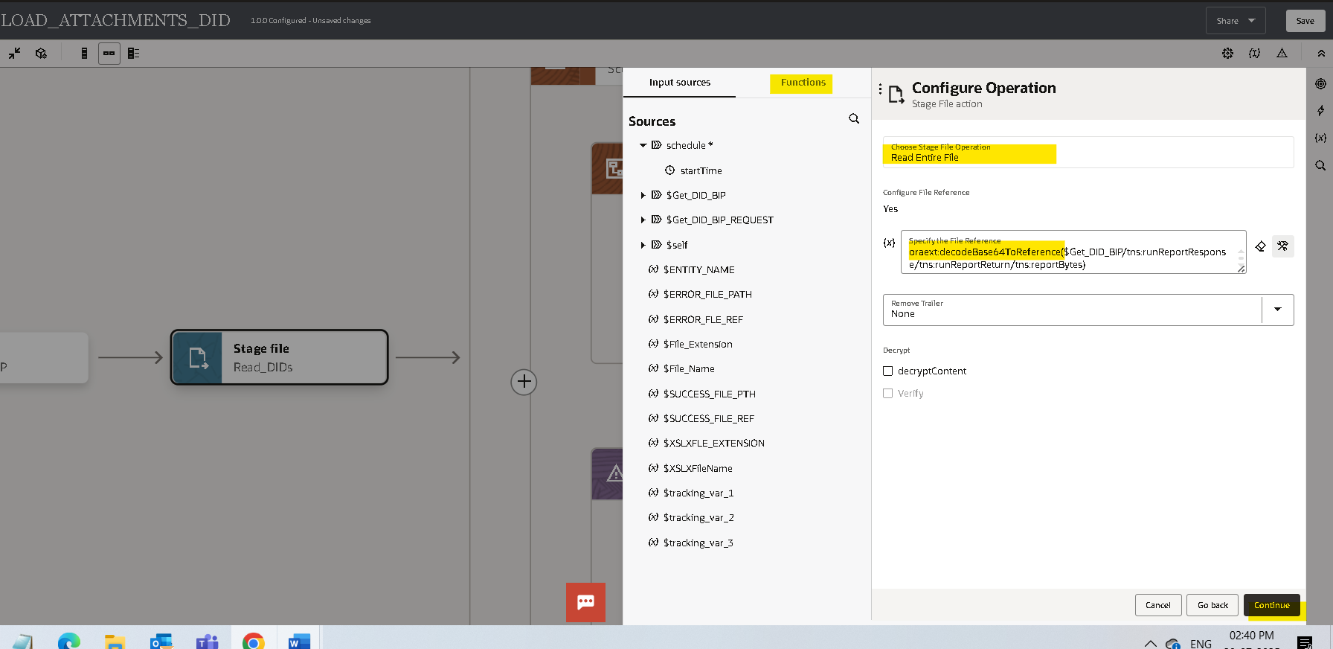
- Since the response from the Soap adapter will be in bytes we must use the decodebase64toreference which is a prebuild function to convert bytes into file reference, click on continue.
- Select file content as CSV.
- We must upload the sample file for reference and make at least single column as mandatory.
- Click on Continue and Finish.
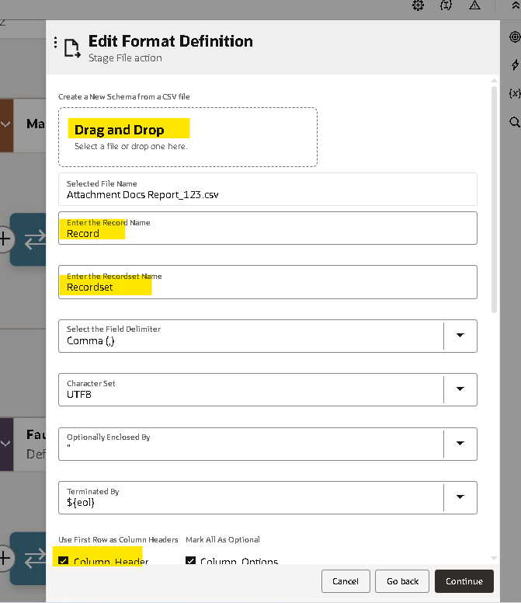

- Use the For loop to iterate for each record that we got from report.
- Map the file reference response from read adapter as repeating element.
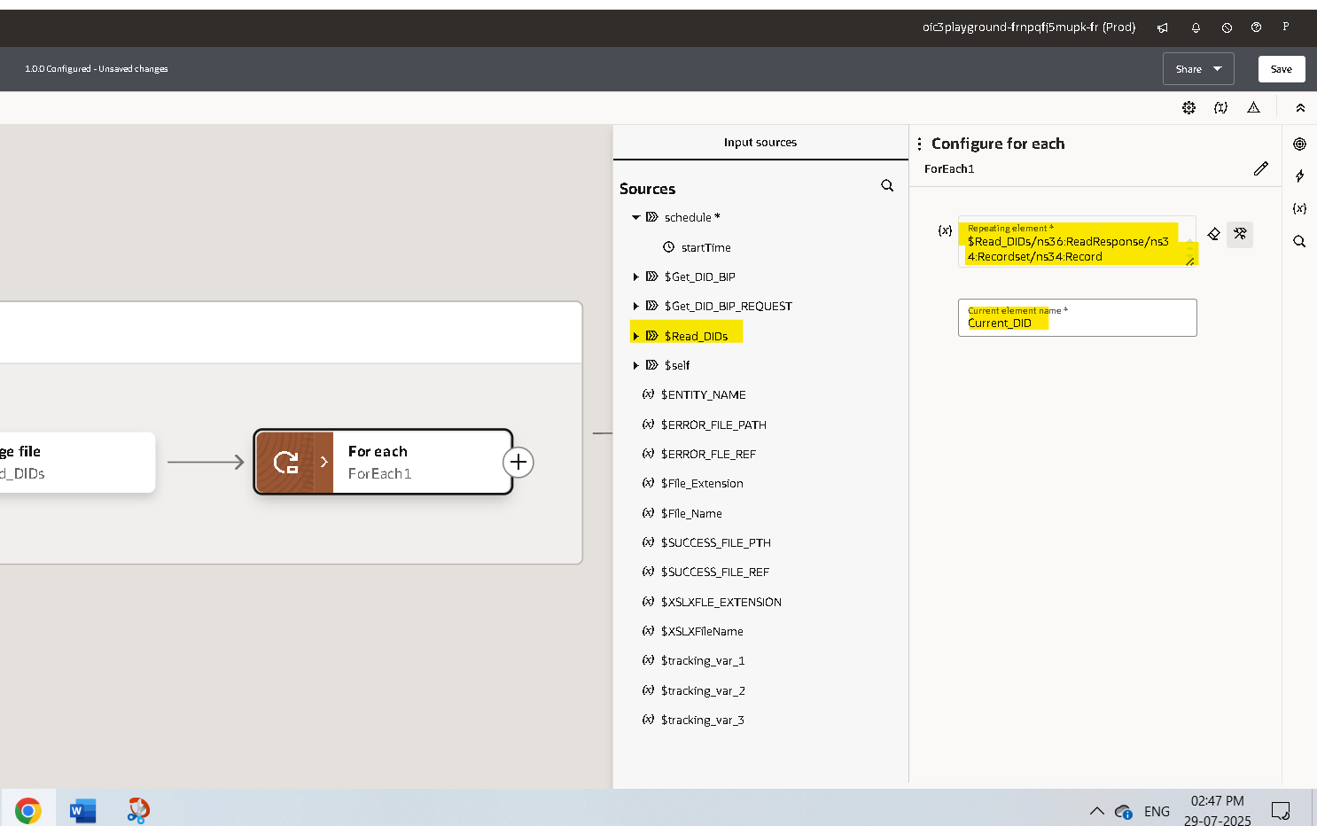
- Use Scope again to handle error occurrence for every record.
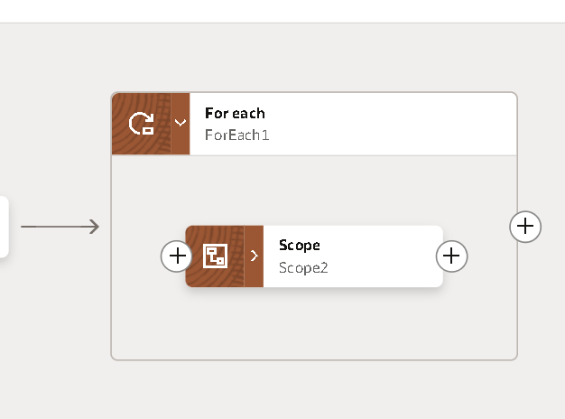
- In the main use the ERP Adapter which we created earlier to download the Attachment from fusion.
- Select Query,Create,Update or Delete Information as operation and continue.
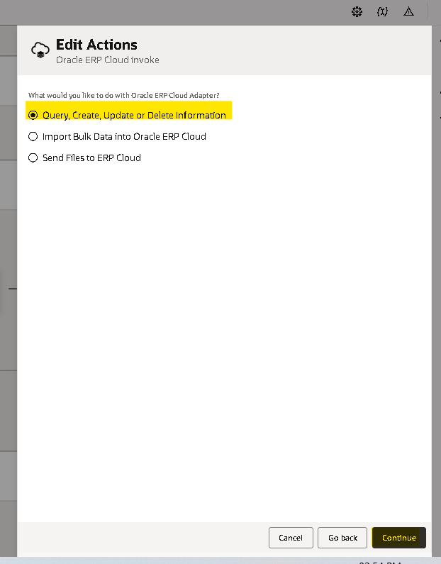
- Select Browsed by as services, and getDocumentForDocumentId as service.
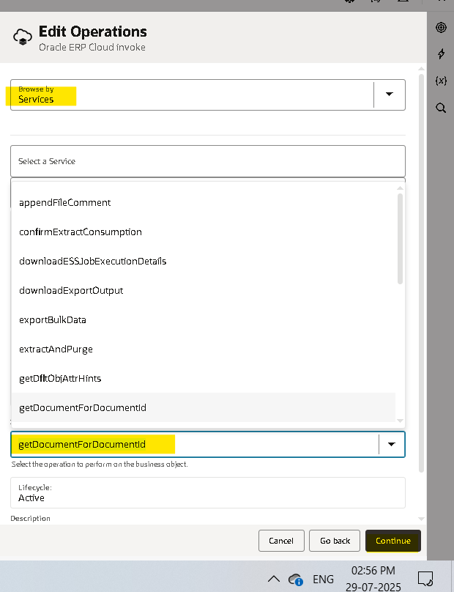
- Click on finish Mapper will generate automatically.
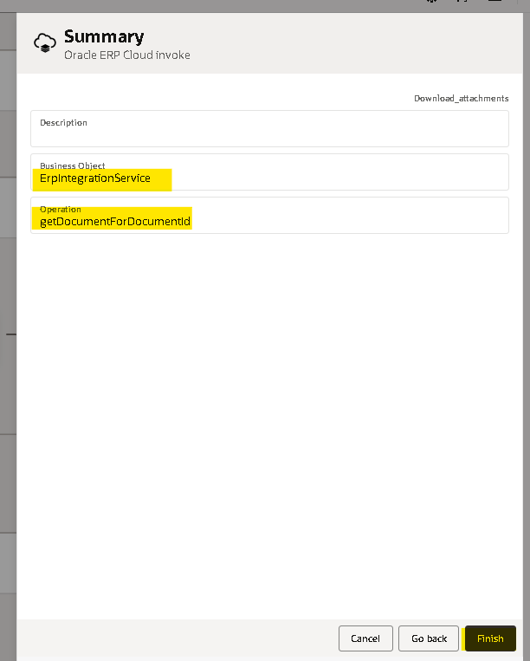

- Map the DID from current iterating record to the target DID node as below and validate.
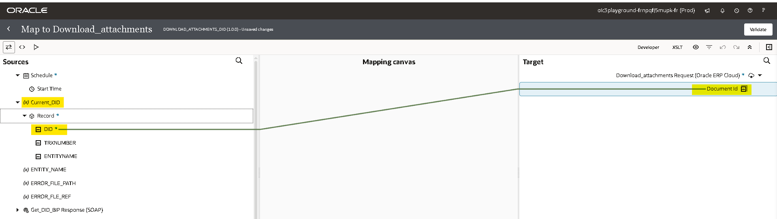

- Now we need to store the response from ERP by using stage adapter.
- Search for ‘stage’ adapter by clicking on the plus (+) icon.
- Select the operation as ‘WriteFile’. Specify the file name and output directory to store the file temporarily.
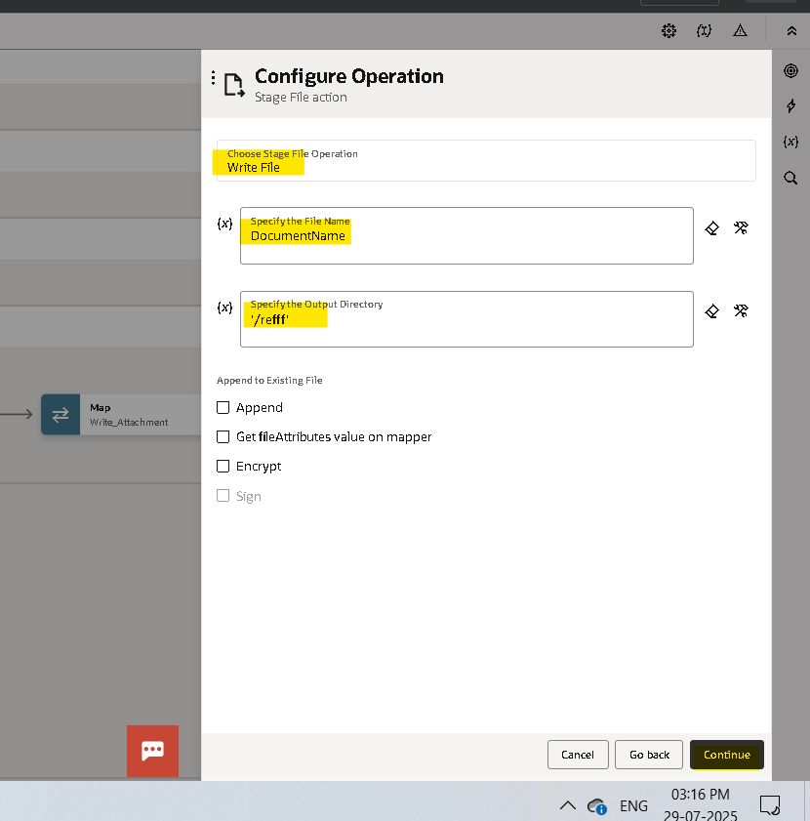
- We will get the response in base64 format so we used opaque schema to get the response from Fusion.
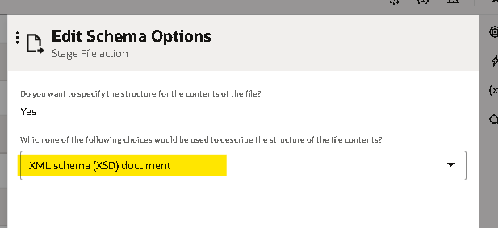
- Upload the Opaque Schema file and finish.
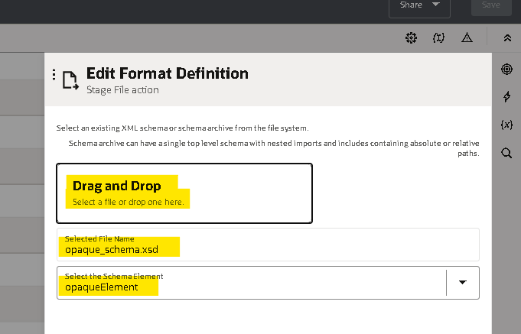
- Mapper will Create for stage write.
- Map the content from ERP adapter response to Opaque Element as below and validate.
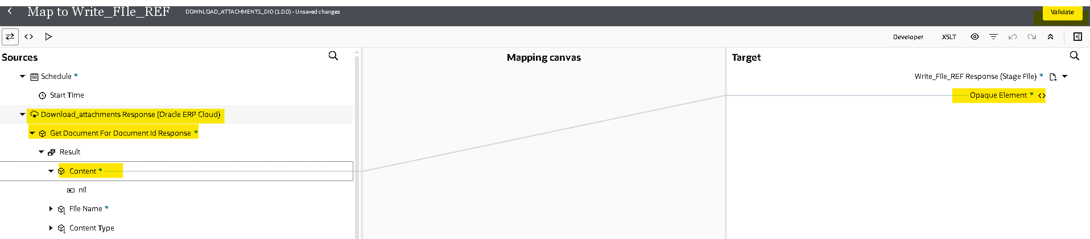
- use assign operator to assign the File name of the content and modify as required using pre build functions like substr.
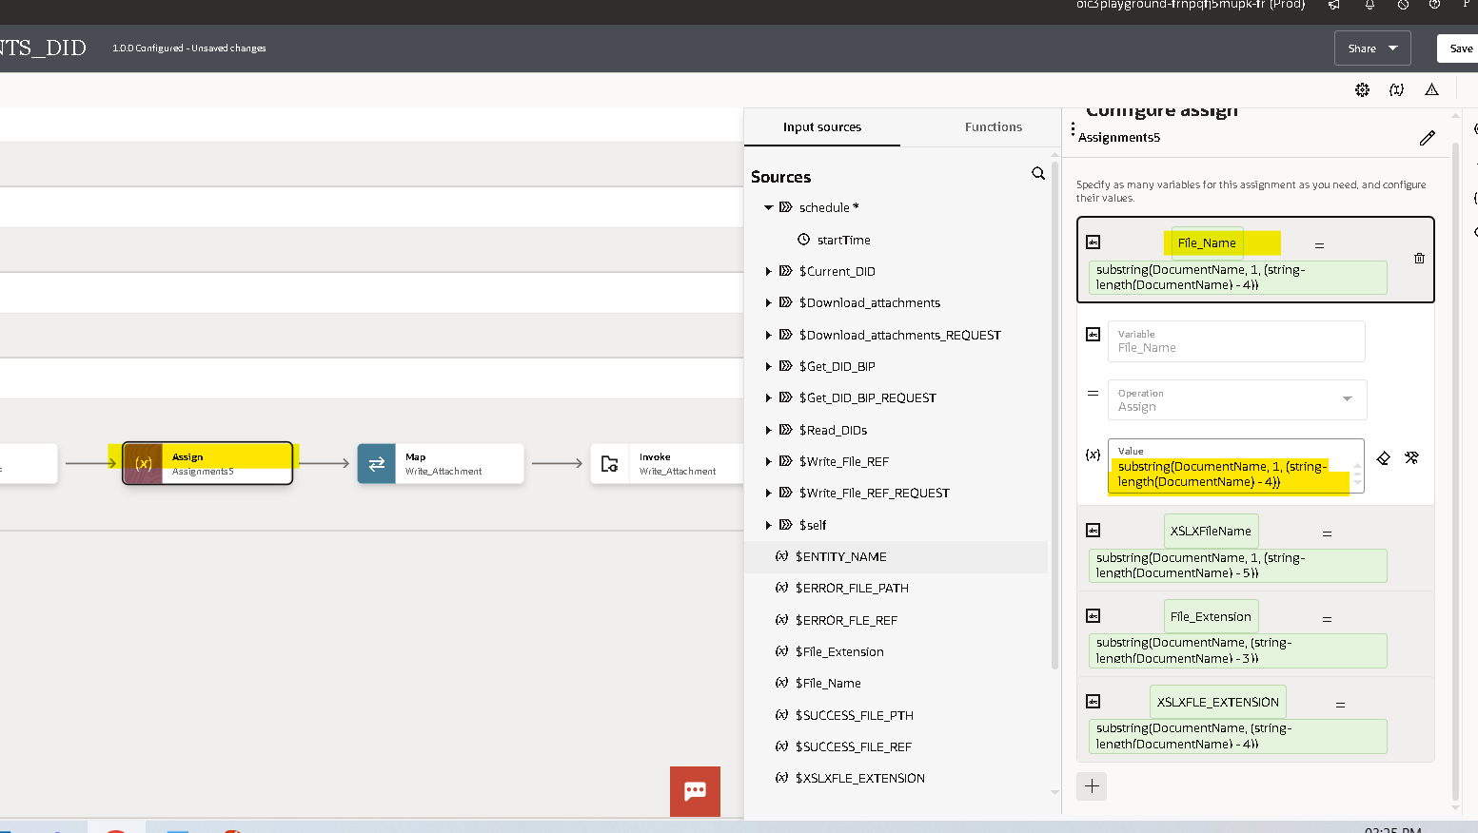
- We Used FTP adapter and Write operation to write the downloaded Attachment in FTP.
- We provided random text for default path and file name which we are modifying later.
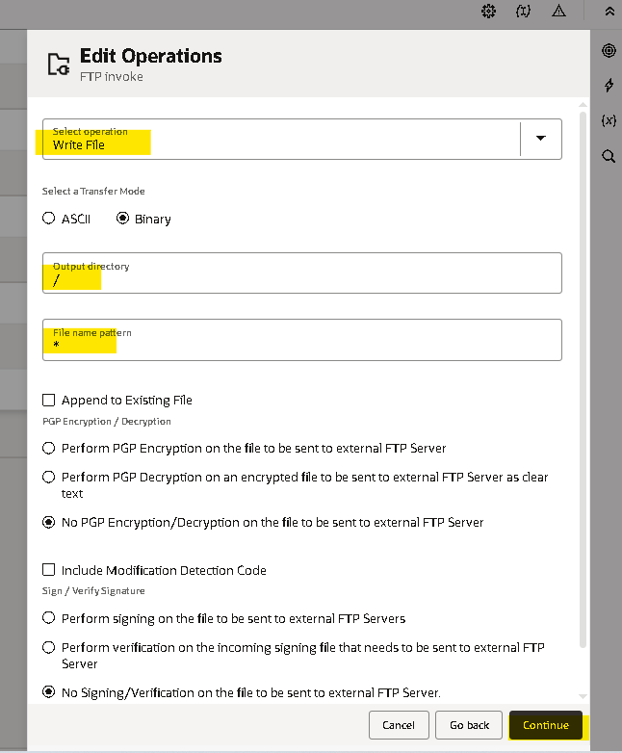
- Mention specific file structure as no and finish.
- Mapper will generate automatically.
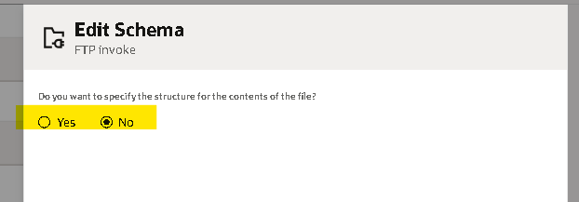
- Map the response from stage write to the target and filename.
- Use the lookup that we created to map the destination FTP path.
dvm:lookupValue ("ENTITY_FILE_PATHS", "ENTITY_NAME", $ENTITY_NAME, "FTP_FILE_PATH", "" )
- Validate and Close.

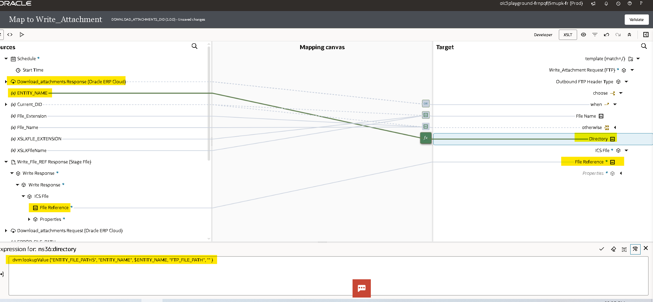
- Now we are using the stage write operation of the stage activity to update the FileReference variable with status and Error columns.
- Choose the file operation as writefile.
- Specify the file name and output directoty to store the file tempararly.
- Here we are using the option append to existing file which appends the every record to the file.
- Select csv as file type for reference.

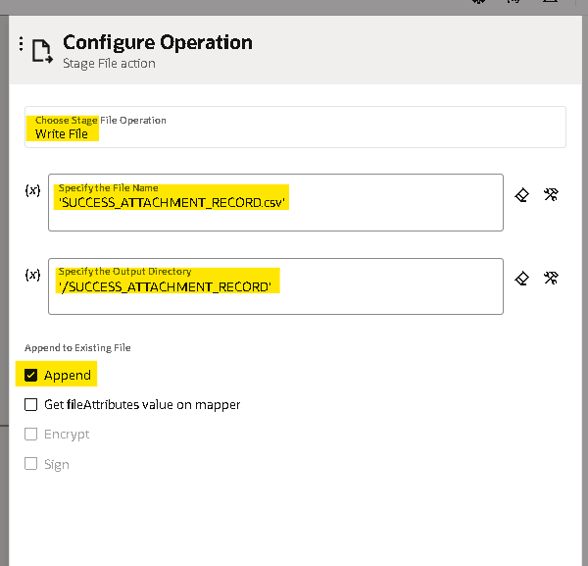S

- Now we need to provide the structure of the file content here we are added two more columns in this file structure with ‘status and error’.
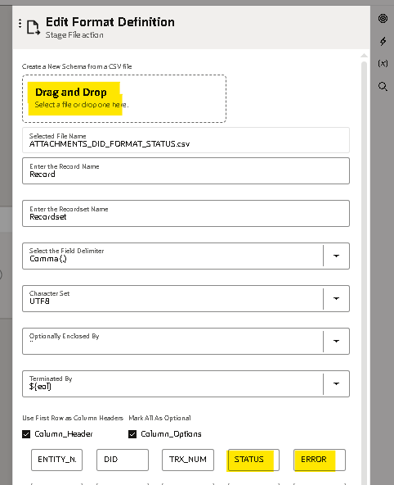
- Continue and finish, mapper will generate.
- Write the status as success,and remaining details from the current record as below and validate.
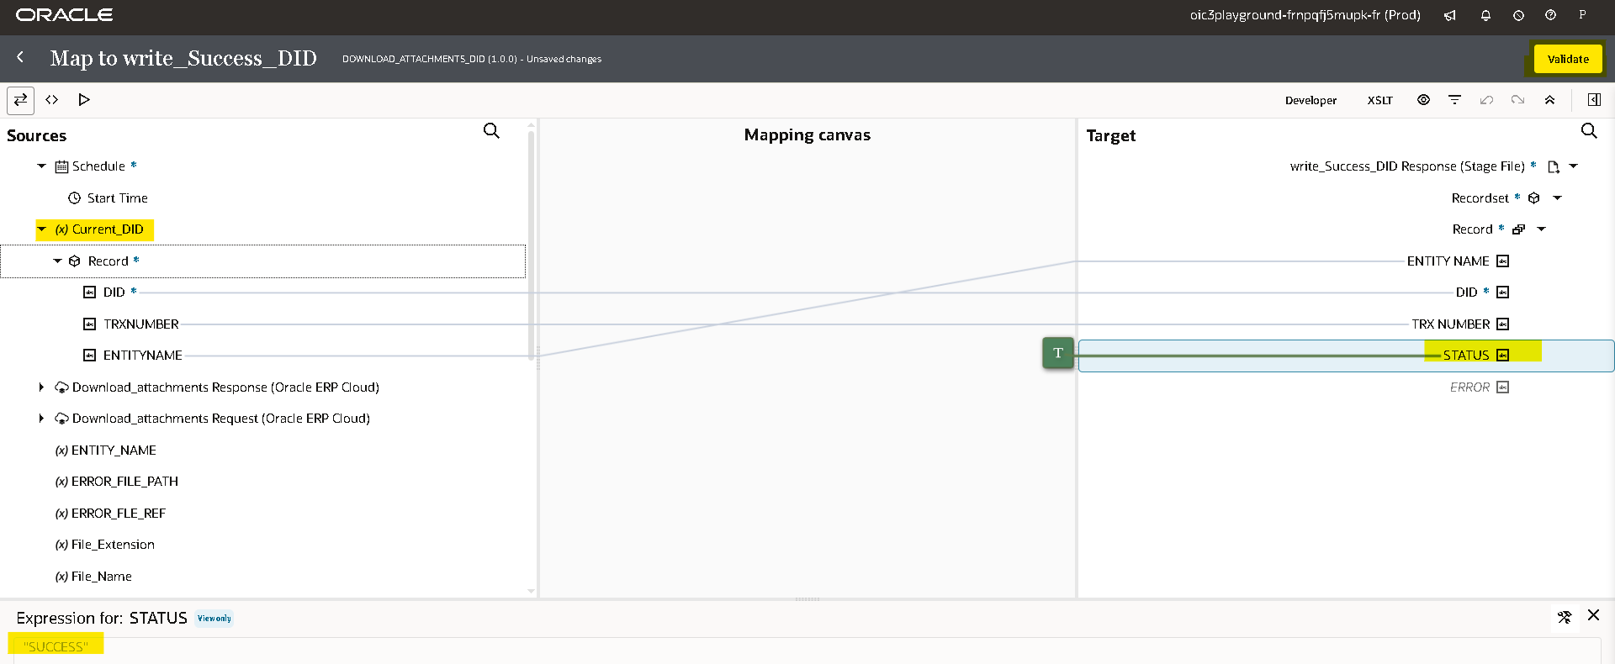
- By clicking on plus(+) icon it will create a variable then from the drop down select the variable which we want to update, assign the FileReference from Write response.
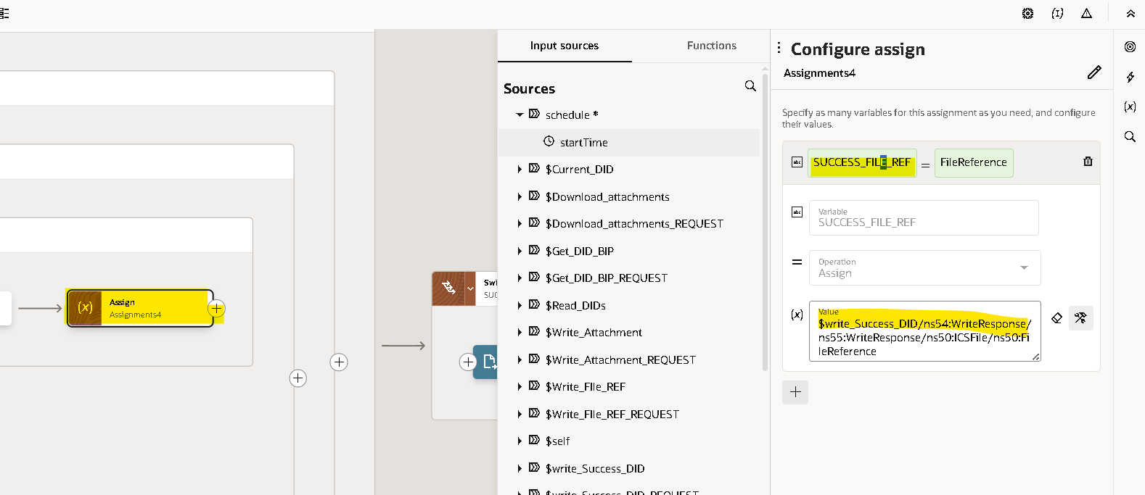
- Now we need to handle the fault handler for the ScopeForEachRecord.
- We will use default handler to be process if any error occurs.
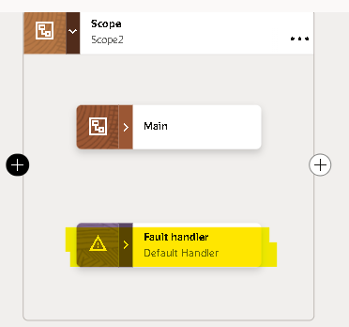
- Again we are using the stage activity to write the file (as done before for the success case) with status as ‘error’ and for error message we will map details of the ScopeForeEachRecordFaultObject details.
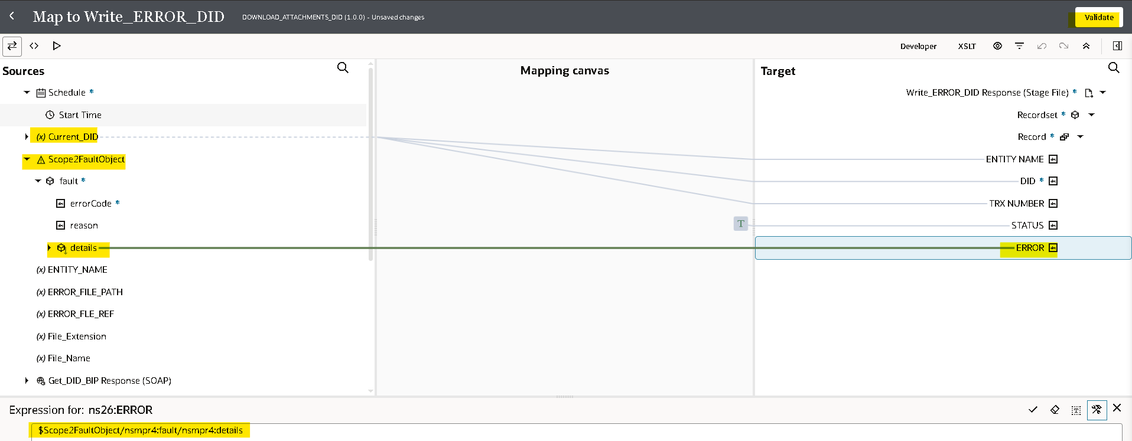
- Assign the file response to a variable ERROR_FLE_REF and save.
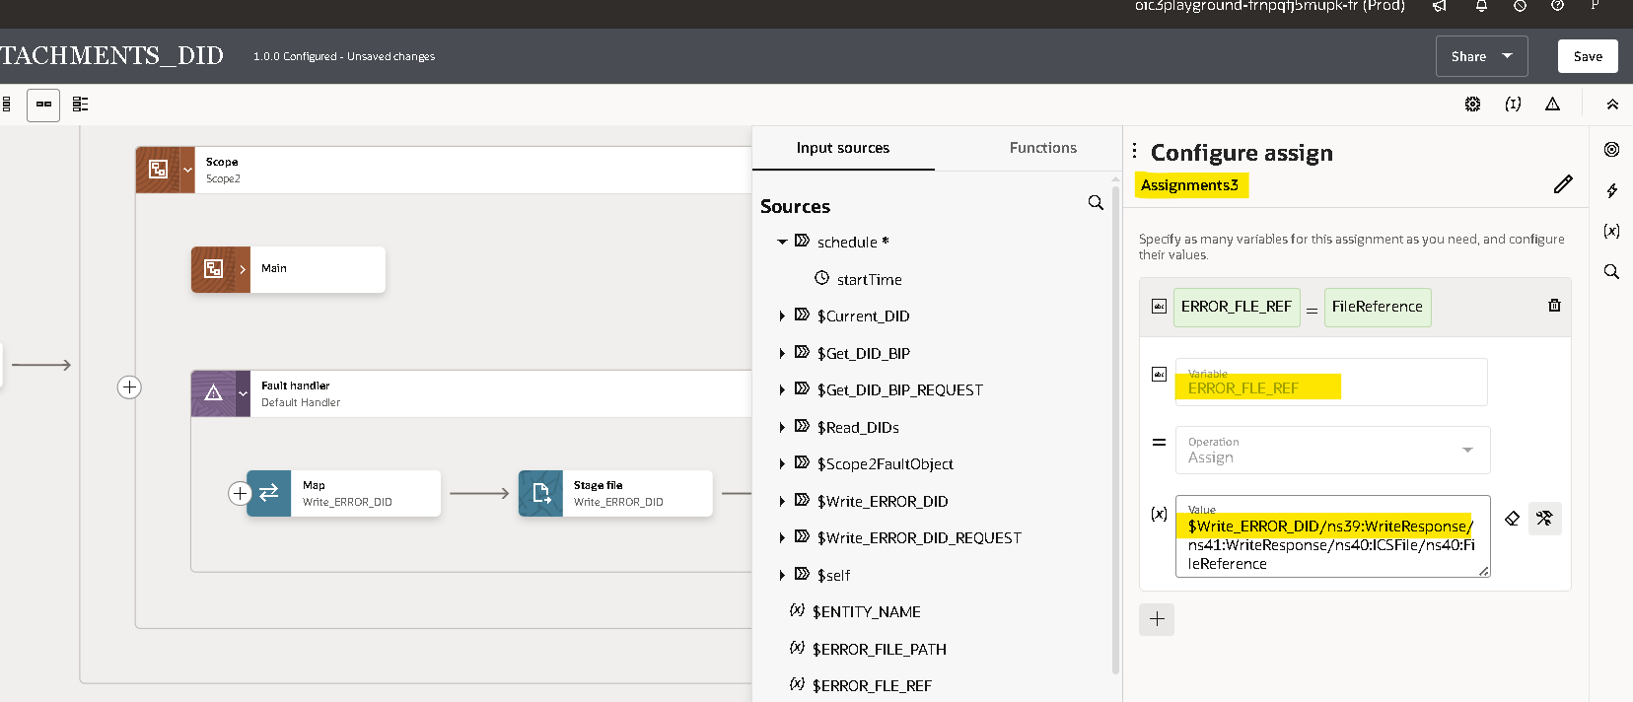
- We used Switch Operation to write into FTP server if there is any Success records.
- Use SUCCESS_FLE_REF!=’’ to check if there is any Success records exists.
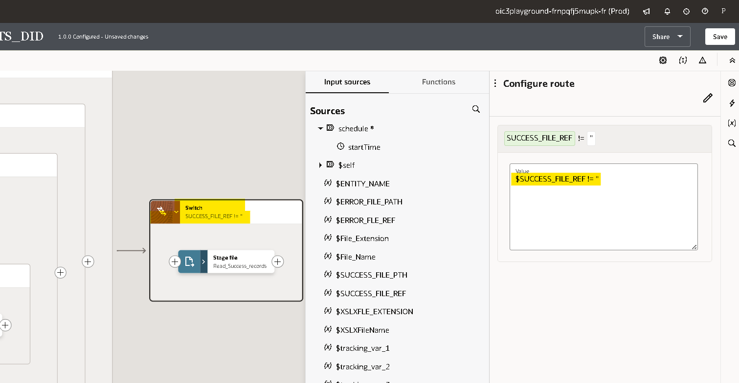
- Use the Stage Read adapter to read the Success records.
- ‘Select Read File in Segments’ file operation to read error file in segments and assign the SUCCESS_FLE_REF as File Reference.
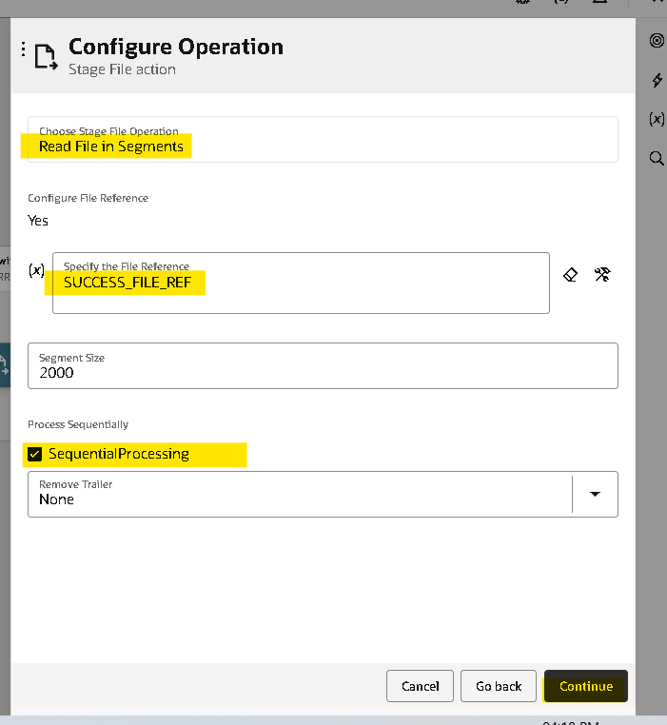
- Select FTP adapter that we created earlier and select Write File as operation.
- Since we can change File pattern and Output directory in mapping we can mention any temparory value.
- Check the Append to existing File to append all the records to the FTP file and click on next.
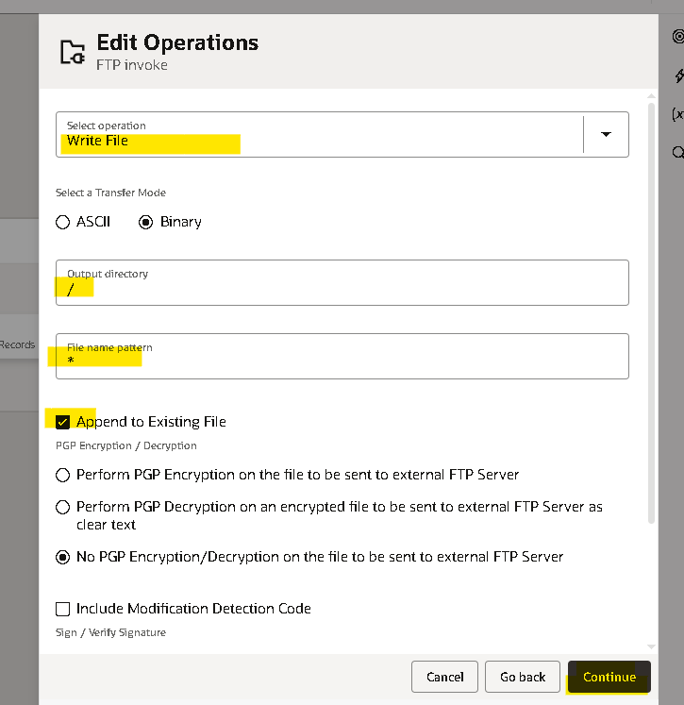

- Select the format as CSV
- Now we need to provide the structure of the file content here we unchecked the use first row as colum headers to read the first record as data.
- Check the summery and click on done.
- Map the required fields from readsuccess records response and file name and directory from variable and lookup.
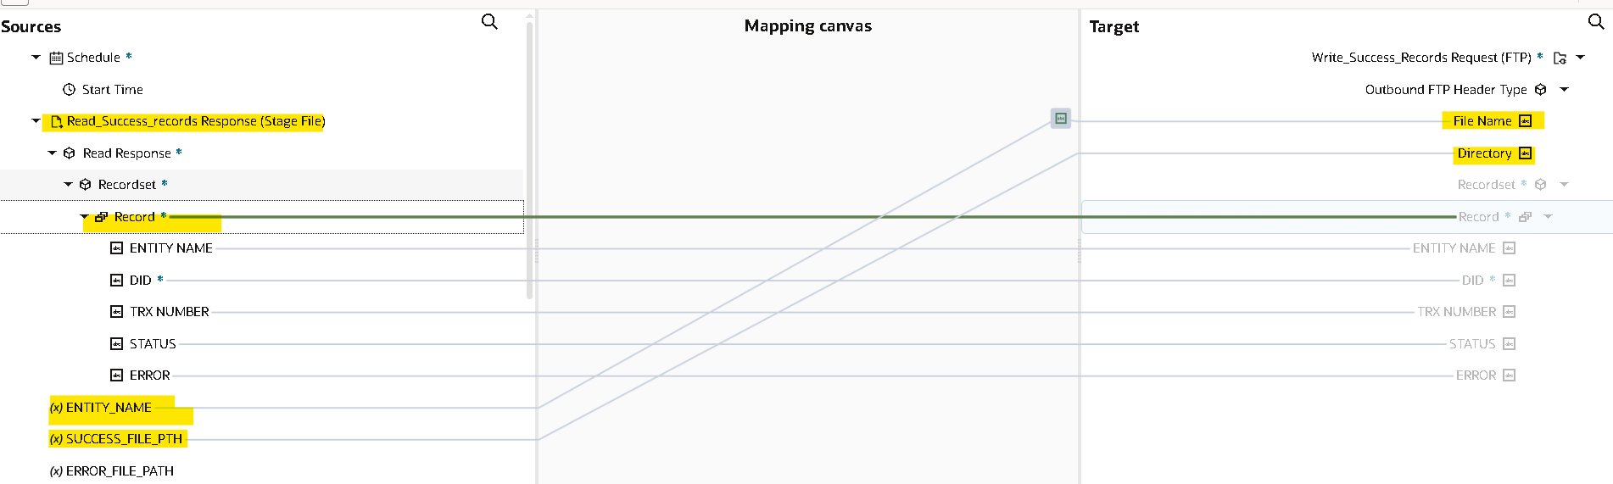

- We need to do the same for error records too by checking the ERROR_FLE_REF!=’’ condition in the switch operation and writing FTP file with Output directory as ERROR_FLE_DIR
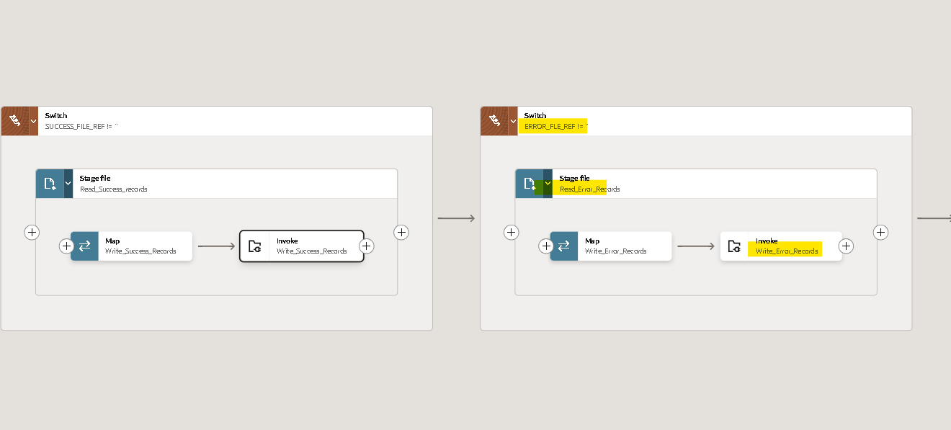.
- Now we will use the notification activity to send a mail in message body we will send the InstanceId of the integration and Filename.
- Drag the notification action on the outside of both the scopes.
- You can provide the details as per your requirement.
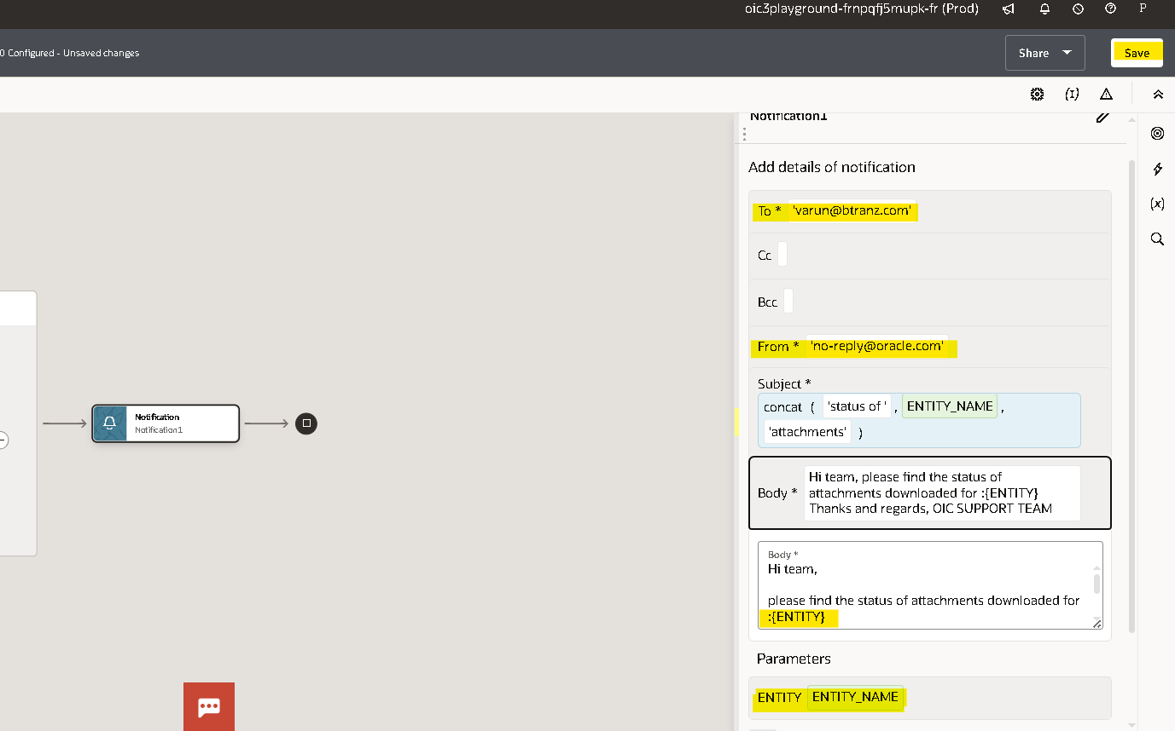
- For every integration we need to assign at least one tracking variable maximum we can assign up to three as it will be used when we are tracking the integration, here you can observe the instance.
- Drag any variable from source to Tracking Field to mention it as Primary variable.
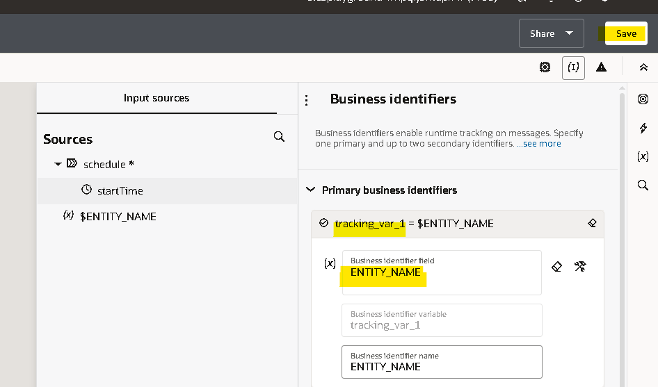
- Once you declare the tracking variable save and close the integration.

Running The Integration:

- Before running an integration we need to activate it initially it will be in draft state after successful creation it will be in configured state after activating it will be in active state.
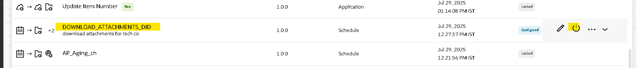
- You can activate and schedule as per your requirement it will run, or you can just activate directly.
- By checking include payload option it helps you to check the payload of each operation in tracking page.
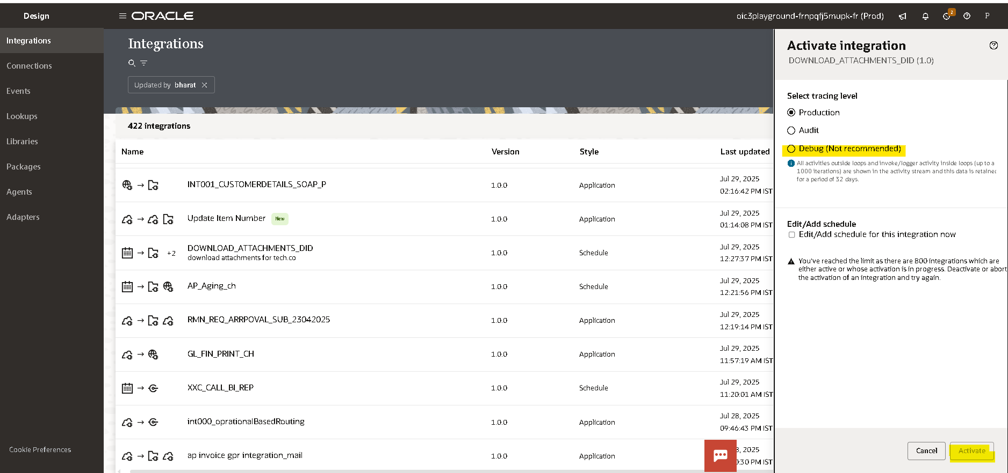

- By clicking on run from menu option it will run the integration.
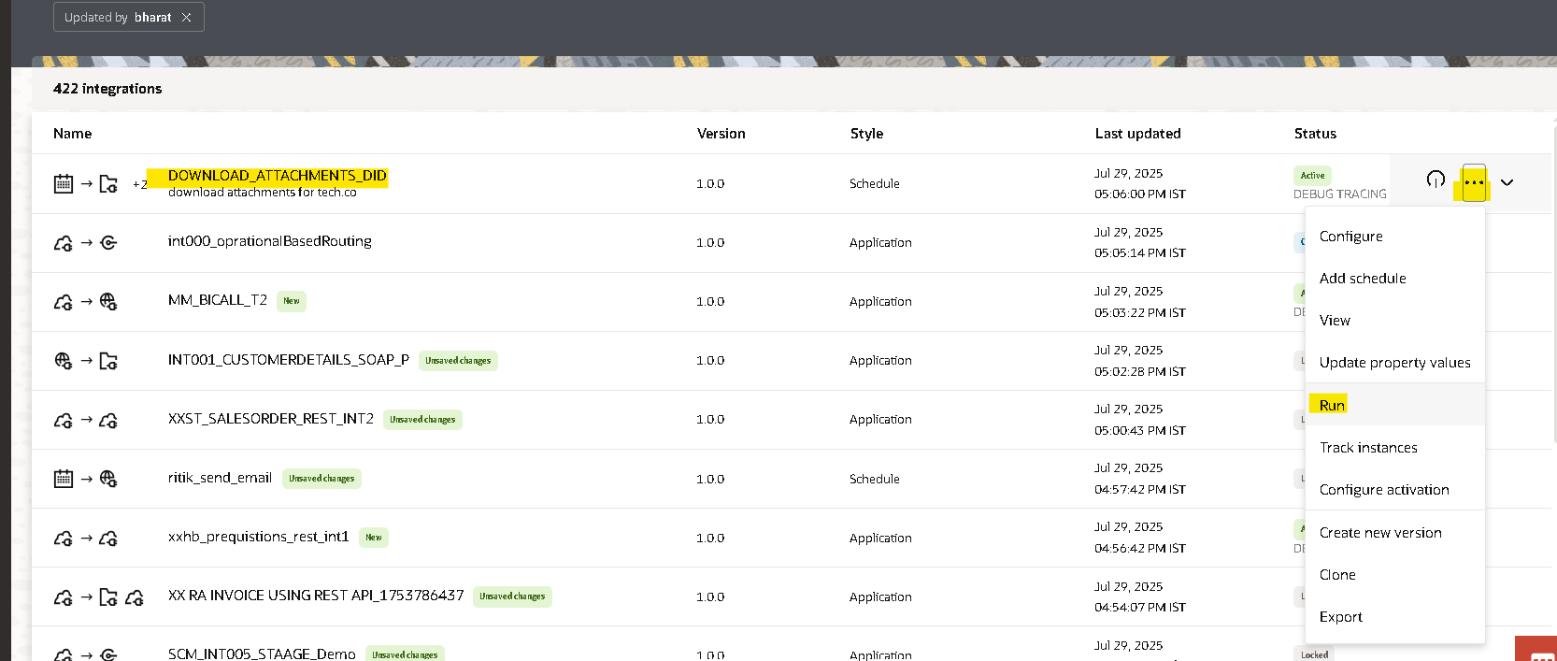

- Provide the required value in schedule parameters and click on run.
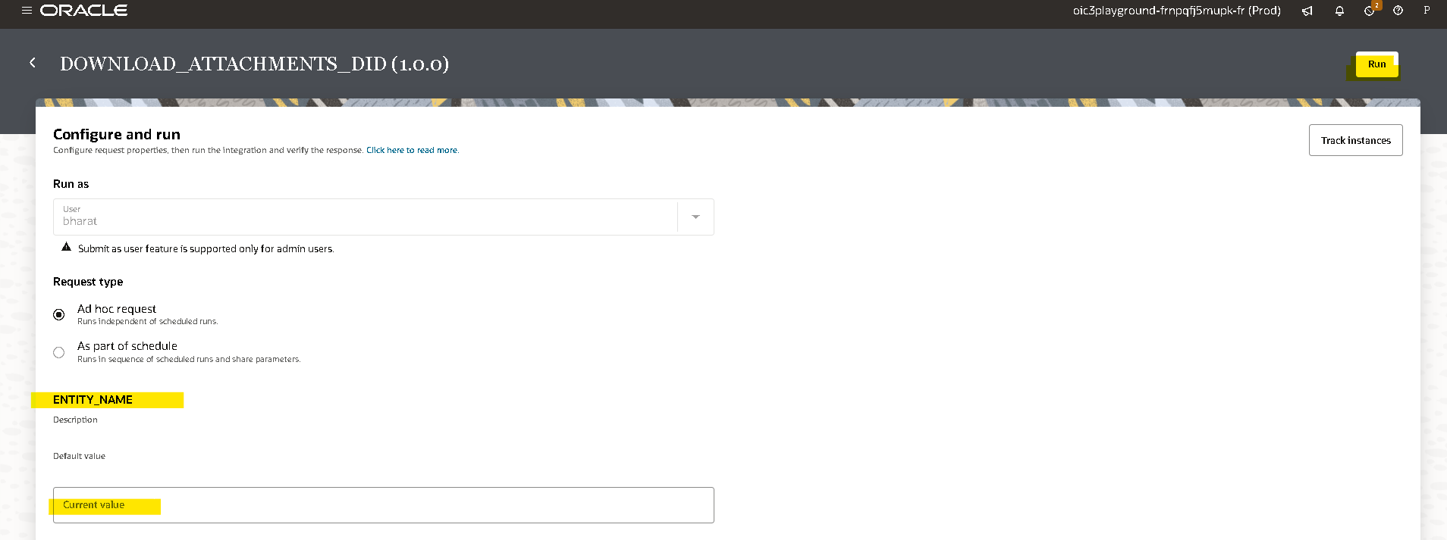
- You will get an InstanceId when you run the integration by clicking on that instance id you will be redirected to tracking page where you can check the status of that integration.
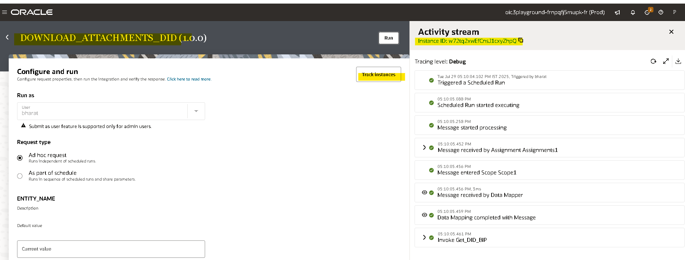

Tracking The Integration:

- To track the integration manually ObservabilityInstancesTracking.

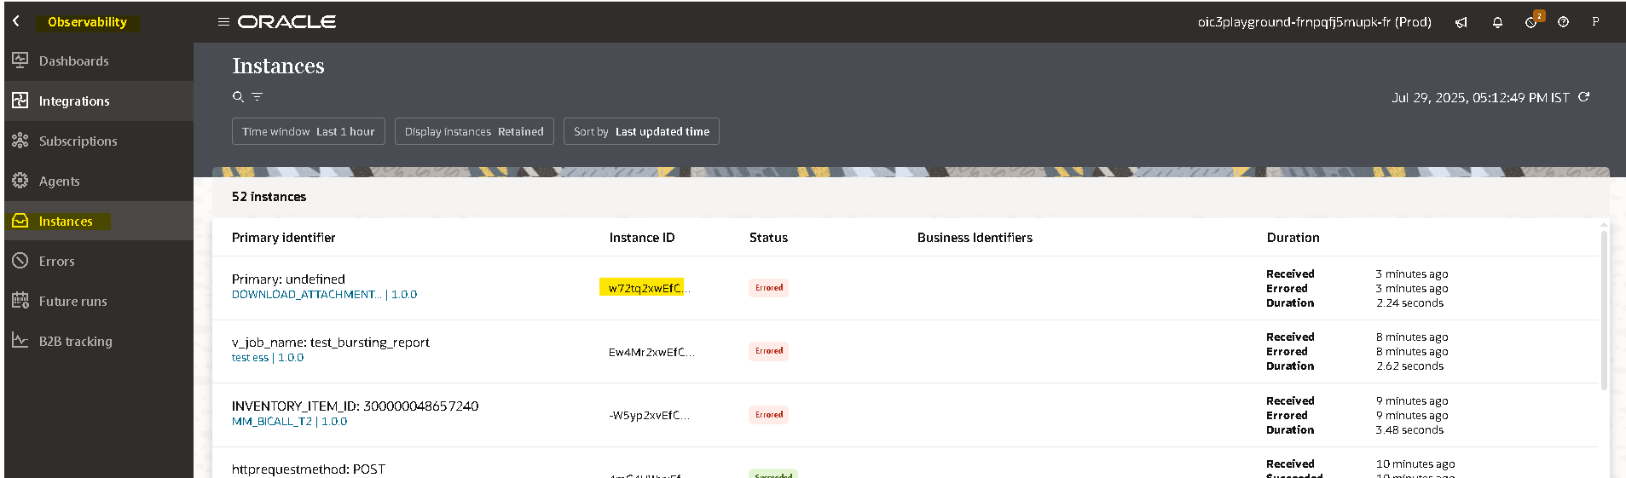

- Here you can observe the InstanceId and status of the integration (if you clicked on InstanceId while running the integration you will be redirected here)
- By clicking on instance id in activity stream you can check the flow of the integration.
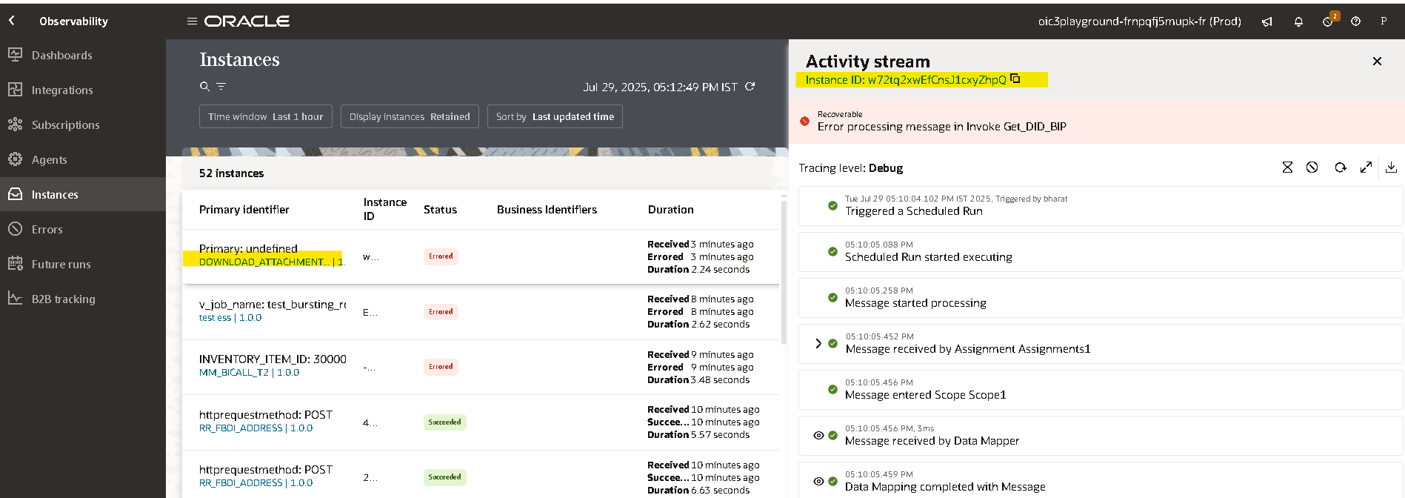

Open and Closed Issues for this Deliverable

Open Issues

ID | Issue | Resolution | Responsibility | Target Date | Impact Date

Closed Issues

ID | Issue | Resolution | Responsibility | Target Date | Impact Date

